SIMATS ENGINEERING
ASSESSMENT TOOL 1

COURSE CODE: CSA1442 COURSE NAME: Compiler Design for Higher
Level Processing

COURSE OUTCOME COVERED

CO2: Construct top-down and bottom up parsers using CFG for parsing conflicts and error recovery for efficient syntax tree generation. (BL3)

Assessment Tool Weightage: 40%

QUESTIONS:4 Total Marks:50
Annexure A

DESIGN TASK

Code of Conduct:

I Gowtham M / 192373060 certify that this submission is my original work and that I have adhered to the guidelines specified for this assessment.
I understand that any violation of academic integrity rules will result in disciplinary action.

Signature of the student:
Gowtham M

Course Faculty

Annexure A

DESIGN TASK

Q1. Predictive Parser Design (Application Level)
Task:
Construct an LL(1) predictive parsing table for the given grammar and demonstrate its application by parsing the specified input string step-by-step, clearly showing stack operations, input symbols, and parsing actions.
.
Grammar:
E → T E'
E' → + T E' | ε
T → F T'
T' → * F T' | ε
F → (E) | id
Conditions:
- Remove left recursion (if any)
- Compute FIRST and FOLLOW sets
- Construct LL(1) parsing table
Test Case:
Input String:
id + id * id
Expected Output:
- Step-by-step parsing actions
- Final result: String Accepted
- 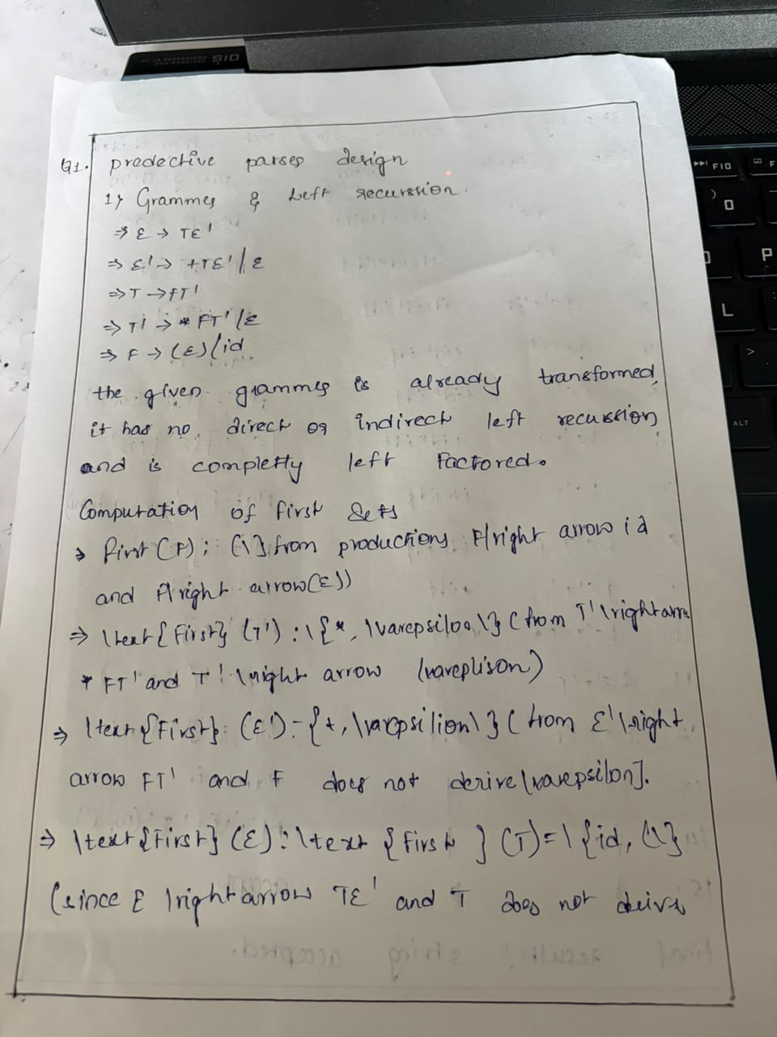
- 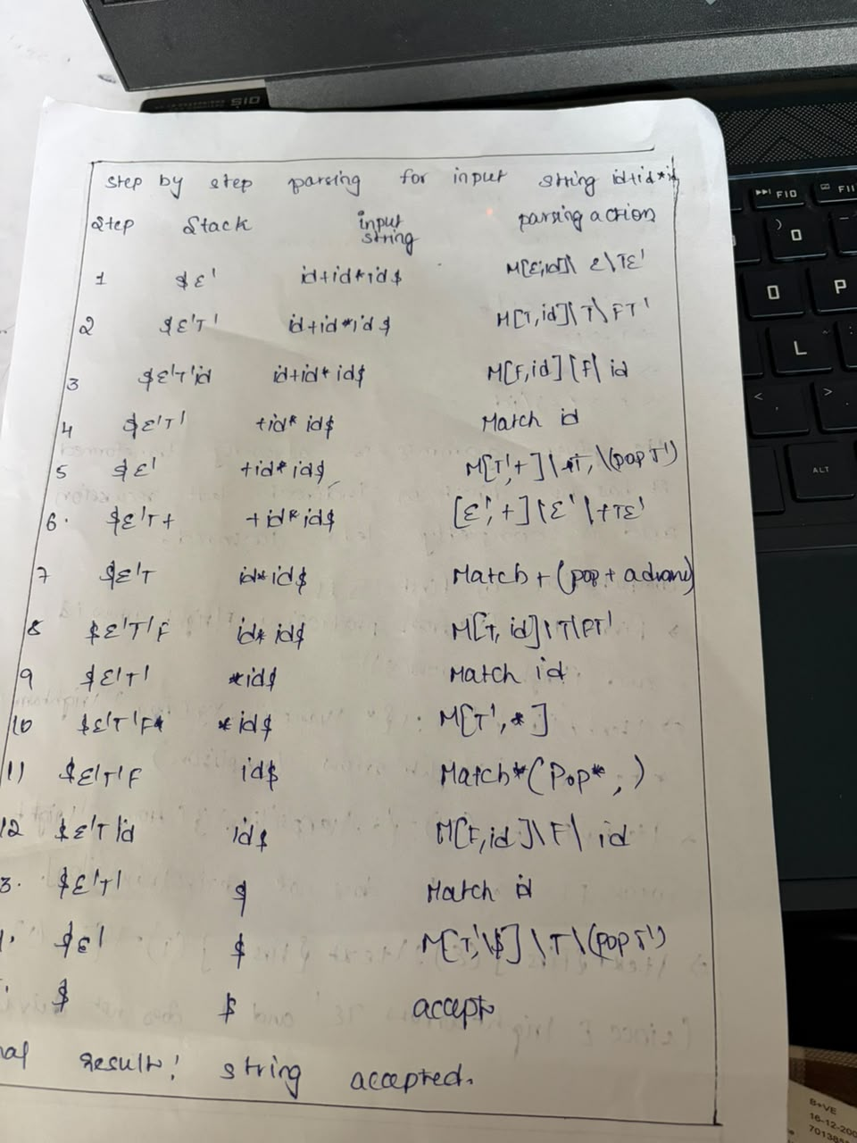

Q2. Shift-Reduce Parsing (Application Level)
Task:
Apply shift-reduce parsing to the given grammar and input string, and demonstrate the complete parsing process by showing each step with stack contents, remaining input, and parsing actions (shift, reduce, accept, or error), clearly indicating all reductions and decisions made during parsing.

Grammar:
E → E + E
E → E * E
E → id
Conditions:
- Show stack, input buffer, and action at each step
- Resolve conflicts using precedence (* has higher precedence than +*)
Test Case:
Input:
id + id * id
Expected Output:
- Sequence of actions: Shift / Reduce / Accept
- Final result: String Accepted

Integrated Design Question (SLR, LALR, CLR Parsing)

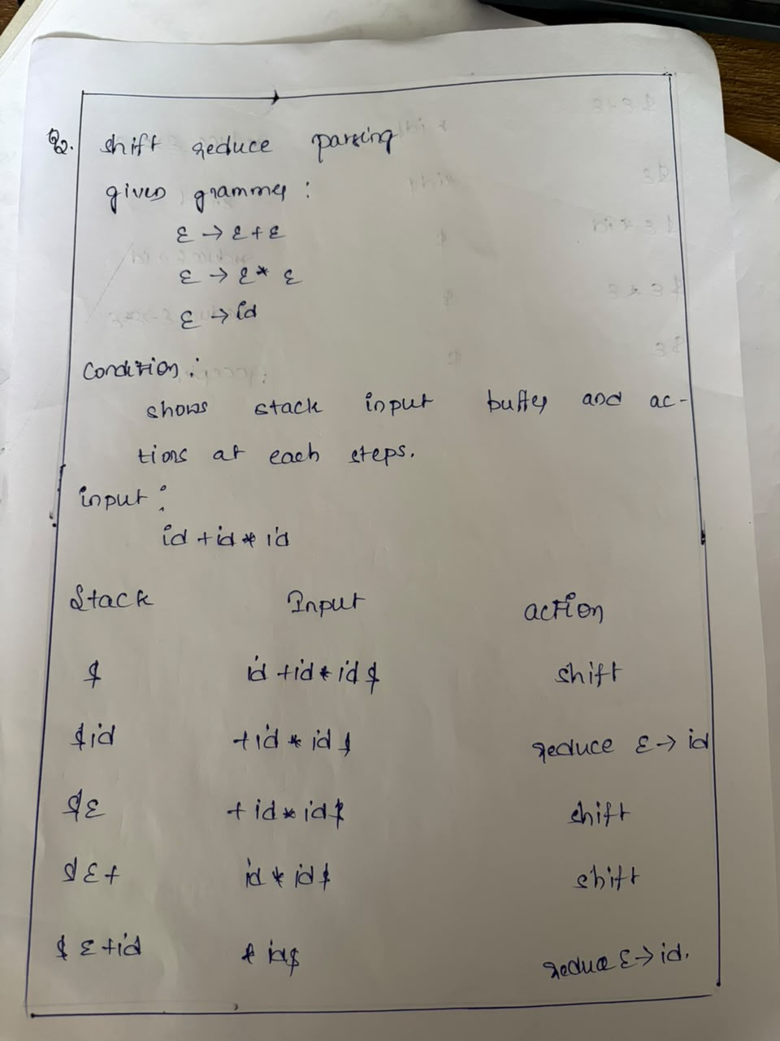
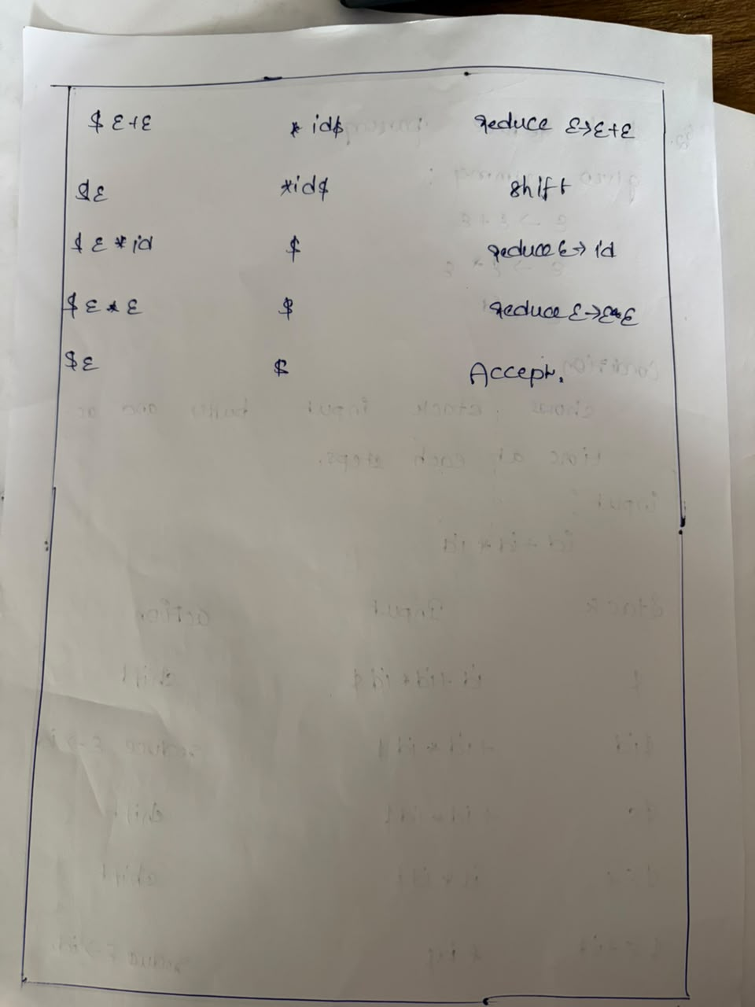

Q3.Construct the LR parsing tables for the given grammar and perform a detailed comparison of different LR parsing techniques (SLR, LALR, and CLR), highlighting their construction steps, state transitions, table sizes, and any conflicts encountered.

S → L = R | R
L → * R | id
R → L

Tasks

(i) CLR (Canonical LR) Design

Construct the canonical collection of LR(1) items
Build the CLR parsing table
Show all item sets and transitions

(ii) SLR Parser Design

Compute FIRST and FOLLOW sets
Construct the SLR parsing table
Identify and explain any shift-reduce or reduce-reduce conflicts

(iii) LALR Parser Design

Merge compatible LR(1) states
Construct the LALR parsing table
Compare with CLR and show how states are reduced

(iv) Parsing Demonstration

Using any one of the constructed parsing tables,
parse the input string:
id = * id
Show:
Stack
Input buffer
Action (Shift / Reduce / Accept)

Grammar Specification & Numbering
The augmented grammar $G'$ with production indices:
- $S'→S$
- $S→L=R$
- $S→R$
- $L→*R$
- $L→\text{id}$
- $R→L$
(i) CLR (Canonical LR / LR(1)) Design
An $\text{LR}\left(1\right)$ item has the form $\left[A→α⋅β,a\right]$, where $a∈\text{FIRST}\left(γ b\right)$ when applying closure to $\left[B→⋅δ,c\right]$ from $\left[A→α⋅Bγ,a\right]$.
1. Canonical Collection of LR(1) Sets of Items
- $I_{0}=\text{CLOSURE}\left(\left\{\left[S'→⋅S,\$\right]\right\}\right)$
  - $\left[S'→⋅S,\$\right]$
  - $\left[S→⋅L=R,\$\right]$
  - $\left[S→⋅R,\$\right]$
  - $\left[L→⋅*R,=/\$\right]$ (from $S→⋅L=R$ and $S→⋅R→⋅L$)
  - $\left[L→⋅\text{id},=/\$\right]$
  - $\left[R→⋅L,\$\right]$
- $\text{GOTO}\left(I_{0},S\right)=I_{1}$
  - $\left[S'→S⋅,\$\right]$
- $\text{GOTO}\left(I_{0},L\right)=I_{2}$
  - $\left[S→L⋅=R,\$\right]$
  - $\left[R→L⋅,\$\right]$
- $\text{GOTO}\left(I_{0},R\right)=I_{3}$
  - $\left[S→R⋅,\$\right]$
- $\text{GOTO}\left(I_{0},*\right)=I_{4}$
  - $\left[L→*⋅R,=/\$\right]$
  - $\left[R→⋅L,=/\$\right]$
  - $\left[L→⋅*R,=/\$\right]$
  - $\left[L→⋅\text{id},=/\$\right]$
- $\text{GOTO}\left(I_{0},\text{id}\right)=I_{5}$
  - $\left[L→\text{id}⋅,=/\$\right]$
- $\text{GOTO}\left(I_{2},=\right)=I_{6}$
  - $\left[S→L=⋅R,\$\right]$
  - $\left[R→⋅L,\$\right]$
  - $\left[L→⋅*R,\$\right]$
  - $\left[L→⋅\text{id},\$\right]$
- $\text{GOTO}\left(I_{4},R\right)=I_{7}$
  - $\left[L→*R⋅,=/\$\right]$
- $\text{GOTO}\left(I_{4},L\right)=I_{8}$
  - $\left[R→L⋅,=/\$\right]$
- $\text{GOTO}\left(I_{4},*\right)=I_{4}$ (loops to itself)
- $\text{GOTO}\left(I_{4},\text{id}\right)=I_{5}$
- $\text{GOTO}\left(I_{6},R\right)=I_{9}$
  - $\left[S→L=R⋅,\$\right]$
- $\text{GOTO}\left(I_{6},L\right)=I_{10}$
  - $\left[R→L⋅,\$\right]$
- $\text{GOTO}\left(I_{6},*\right)=I_{11}$
  - $\left[L→*⋅R,\$\right]$
  - $\left[R→⋅L,\$\right]$
  - $\left[L→⋅*R,\$\right]$
  - $\left[L→⋅\text{id},\$\right]$
- $\text{GOTO}\left(I_{6},\text{id}\right)=I_{12}$
  - $\left[L→\text{id}⋅,\$\right]$
- $\text{GOTO}\left(I_{11},R\right)=I_{13}$
  - $\left[L→*R⋅,\$\right]$
- $\text{GOTO}\left(I_{11},L\right)=I_{10}$
- $\text{GOTO}\left(I_{11},*\right)=I_{11}$ (loops to itself)
- $\text{GOTO}\left(I_{11},\text{id}\right)=I_{12}$
Total CLR states: 14 states ($I_{0}$ through $I_{13}$).
2. CLR(1) Parsing Table
State | id | ∗ | = | $ | S | L | R
0 | $$s_{5}$$ | $$s_{4}$$ |  |  | 1 | 2 | 3
1 |  |  |  | acc
2 |  |  | $$s_{6}$$ | $$r_{5}$$
3 |  |  |  | $$r_{2}$$
4 | $$s_{5}$$ | $$s_{4}$$ |  |  |  | 8 | 7
5 |  |  | $$r_{4}$$ | $$r_{4}$$
6 | $$s_{12}$$ | $$s_{11}$$ |  |  |  | 10 | 9
7 |  |  | $$r_{3}$$ | $$r_{3}$$
8 |  |  | $$r_{5}$$ | $$r_{5}$$
9 |  |  |  | $$r_{1}$$
10 |  |  |  | $$r_{5}$$
11 | $$s_{12}$$ | $$s_{11}$$ |  |  |  | 10 | 13
12 |  |  |  | $$r_{4}$$
13 |  |  |  | $$r_{3}$$
Notice: In state 2, on terminal =, the action is $s_{6}$. On terminal $ the action is $r_{5}$ ($R→L$). Because their lookaheads do not intersect, CLR(1) is completely conflict-free.
(ii) SLR Parser Design
1. FIRST and FOLLOW Sets
- $\text{FIRST}\left(S\right)=\text{FIRST}\left(L\right)∪\text{FIRST}\left(R\right)=\left\{*,\text{id}\right\}$
- $\text{FIRST}\left(L\right)=\left\{*,\text{id}\right\}$
- $\text{FIRST}\left(R\right)=\text{FIRST}\left(L\right)=\left\{*,\text{id}\right\}$
- $\text{FOLLOW}\left(S\right)$:
  - $S$ is start symbol $⟹\left\{\$\right\}$
  - $\text{FOLLOW}\left(S\right)=\left\{\$\right\}$
- $\text{FOLLOW}\left(L\right)$:
  - From $S→L=R⟹=$
  - From $R→L⟹\text{FOLLOW}\left(R\right)$
  - Thus $\text{FOLLOW}\left(L\right)=\left\{=\right\}∪\text{FOLLOW}\left(R\right)=\left\{=,\$\right\}$
- $\text{FOLLOW}\left(R\right)$:
  - From $S→L=R⟹\text{FOLLOW}\left(S\right)=\left\{\$\right\}$
  - From $S→R⟹\text{FOLLOW}\left(S\right)=\left\{\$\right\}$
  - From $L→*R⟹\text{FOLLOW}\left(L\right)=\left\{=,\$\right\}$
  - Thus $\text{FOLLOW}\left(R\right)=\left\{=,\$\right\}$
2. LR(0) Canonical Collection & SLR Conflict Analysis
The LR(0) state $I_{2}$ consists of:
$$I_{2}=\left\{S→L⋅=R, R→L⋅\right\}$$
Under SLR rules:
- For $\left[S→L⋅=R\right]$, seeing terminal = triggers a Shift to state 6 ($\text{action}\left[2,=\right]=\text{shift}$).
- For $\left[R→L⋅\right]$, a reduction by $R→L$ occurs for every terminal $a∈\text{FOLLOW}\left(R\right)$.
- Since $\text{FOLLOW}\left(R\right)=\left\{=,\$\right\}$, on input =, the parser must also Reduce by rule 5 ($R→L$).
Because both shift and reduce actions map to the same entry:
$$\text{action}\left[2,=\right]=\left\{s_{6},r_{5}\right\}$$
This produces a Shift-Reduce (S/R) conflict in State 2 on terminal =. Therefore, the grammar is not SLR(1).
(iii) LALR Parser Design
LALR(1) merges LR(1) states that share identical LR(0) cores (items ignoring lookaheads).
1. Merging Compatible LR(1) States
- $I_{4}$ and $I_{11}$ have core $\left\{L→*⋅R,R→⋅L,L→⋅*R,L→⋅\text{id}\right\}$.
  - Lookaheads for $I_{4}$: $\left\{=,\$\right\}$; for $I_{11}$: $\left\{\$\right\}$.
  - Merged into $I_{4,11}$ with lookaheads $\left\{=,\$\right\}$.
- $I_{5}$ and $I_{12}$ have core $\left\{L→\text{id}⋅\right\}$.
  - Merged into $I_{5,12}$ with lookaheads $\left\{=,\$\right\}$.
- $I_{7}$ and $I_{13}$ have core $\left\{L→*R⋅\right\}$.
  - Merged into $I_{7,13}$ with lookaheads $\left\{=,\$\right\}$.
- $I_{8}$ and $I_{10}$ have core $\left\{R→L⋅\right\}$.
  - Merged into $I_{8,10}$ with lookaheads $\left\{=,\$\right\}$.
Remaining states ($I_{0},I_{1},I_{2},I_{3},I_{6},I_{9}$) remain unique.
This reduces the state count from 14 (CLR) down to 10 (LALR), exactly equal to the number of LR(0) states.
2. LALR(1) Parsing Table
State | id | ∗ | = | $ | S | L | R
0 | $$s_{5,12}$$ | $$s_{4,11}$$ |  |  | 1 | 2 | 3
1 |  |  |  | acc
2 |  |  | $$s_{6}$$ | $$r_{5}$$
3 |  |  |  | $$r_{2}$$
4,11 | $$s_{5,12}$$ | $$s_{4,11}$$ |  |  |  | 8,10 | 7,13
5,12 |  |  | $$r_{4}$$ | $$r_{4}$$
6 | $$s_{5,12}$$ | $$s_{4,11}$$ |  |  |  | 8,10 | 9
7,13 |  |  | $$r_{3}$$ | $$r_{3}$$
8,10 |  |  | $$r_{5}$$ | $$r_{5}$$
9 |  |  |  | $$r_{1}$$
Notice: State 2 was not merged with any other state, so $\text{action}\left[2,=\right]=s_{6}$ and $\text{action}\left[2,\$\right]=r_{5}$ remain cleanly separated. No conflicts are introduced during merging, making the grammar LALR(1).
Comparative Evaluation
Feature / Metric | SLR(1) | LALR(1) | CLR(1)
Item Form | LR(0) items $\left[A→α⋅β\right]$ | LR(1) items merged by core | LR(1) items $\left[A→α⋅β,a\right]$
Reduction Criteria | Reduces on all $a∈\text{FOLLOW}\left(A\right)$ | Reduces only on specific lookaheads | Reduces only on specific lookaheads
State Count | 10 states | 10 states | 14 states
Conflicts Encountered | 1 Shift/Reduce conflict in $I_{2}$ on = | None | None
Grammar Acceptance | Fails (Not SLR) | Succeeds (Is LALR) | Succeeds (Is CLR)
Parsing Power | Weakest | Moderate (Industry standard) | Most powerful
(iv) Parsing Demonstration
Parsing input string: $\text{id}=*\text{id}$ using the LALR(1) parsing table.
Step | Stack | Input Buffer | Action
1 | $$0$$ | $$\text{id}=*\text{id}\$$$ | Shift to state $5,12$ ($s_{5,12}$)
2 | $$0 \text{id} 5,12$$ | $$=*\text{id}\$$$ | Reduce by $L→\text{id}$ ($r_{4}$); pop $\text{id}$, $\text{GOTO}\left(0,L\right)=2$
3 | $$0 L 2$$ | $$=*\text{id}\$$$ | Shift to state $6$ ($s_{6}$)
4 | $$0 L 2 = 6$$ | $$*\text{id}\$$$ | Shift to state $4,11$ ($s_{4,11}$)
5 | $$0 L 2 = 6 * 4,11$$ | $$\text{id}\$$$ | Shift to state $5,12$ ($s_{5,12}$)
6 | $$0 L 2 = 6 * 4,11 \text{id} 5,12$$ | $$\$$$ | Reduce by $L→\text{id}$ ($r_{4}$); pop $\text{id}$, $\text{GOTO}\left(4,11,L\right)=8,10$
7 | $$0 L 2 = 6 * 4,11 L 8,10$$ | $$\$$$ | Reduce by $R→L$ ($r_{5}$); pop $L$, $\text{GOTO}\left(4,11,R\right)=7,13$
8 | $$0 L 2 = 6 * 4,11 R 7,13$$ | $$\$$$ | Reduce by $L→*R$ ($r_{3}$); pop $*R$, $\text{GOTO}\left(6,L\right)=8,10$
9 | $$0 L 2 = 6 L 8,10$$ | $$\$$$ | Reduce by $R→L$ ($r_{5}$); pop $L$, $\text{GOTO}\left(6,R\right)=9$
10 | $$0 L 2 = 6 R 9$$ | $$\$$$ | Reduce by $S→L=R$ ($r_{1}$); pop $L=R$, $\text{GOTO}\left(0,S\right)=1$
11 | $$0 S 1$$ | $$\$$$ | Accept

Q4. Critically evaluate the effectiveness of Parsing Expression Grammars (PEG) as a modern parsing technique by comparing them with traditional LL and LR parsers in terms of ambiguity handling, grammar expressiveness, implementation complexity, performance, and real-world applicability.

Your answer should:
- Analyze how PEG parsers resolve ambiguity differently from CFG-based parsers
- Compare PEG with LL and LR parsing in terms of:
  - Grammar expressiveness
  - Ease of implementation
  - Performance and backtracking
- Examine real-world adoption (e.g., Python’s PEG parser) and justify why PEG was preferred
- Critically evaluate limitations of PEG (e.g., lack of left recursion support, ordered choice behavior)
- Conclude whether PEG is suitable for all programming languages or only specific cases, with justification
Ambiguity Resolution: Recognition vs. Generation
The fundamental difference between Context-Free Grammars (CFGs used in LL and LR parsers) and Parsing Expression Grammars (PEGs) lies in their formal nature:
- CFGs are generative systems. An alternation $A→α∣β$ states that $A$ can be replaced by either $α$ or $β$ non-deterministically. If an input string yields more than one valid parse tree or derivation, the grammar itself is ambiguous. Determining whether an arbitrary CFG is ambiguous is mathematically undecidable.
- PEGs are recognition systems. PEGs replace the unordered alternative operator with prioritized (ordered) choice:
$$e_{1}\backslash mathbin/e_{2}$$
The parser strictly evaluates $e_{1}$ first. If $e_{1}$ matches the current input prefix, that choice is committed, and $e_{2}$ is never evaluated—even if $e_{1}$ leads to a downstream parsing failure. Consequently, an expression in PEG can produce at most one valid parse tree for any input string. PEGs are unambiguous by definition.
Dangling-Else Resolution:

CFG: Statement -> "if" Expr "then" Statement ("else" Statement)?
[Inherently ambiguous without out-of-band associativity/precedence rules]

PEG: Statement <- "if" Expr "then" Statement "else" Statement
/ "if" Expr "then" Statement
[Naturally unambiguous: the longer alternative is tried first]
In addition to ordered choice, PEGs introduce syntactic predicates:
- The &e (and-predicate): Matches $e$ without consuming any input (syntactic lookahead).
- The !e (not-predicate): Succeeds if and only if $e$ fails to match at the current position, consuming zero input.
These predicates turn PEGs into deterministic, backtracking top-down recognizers, eliminating traditional parser-generation shift-reduce or reduce-reduce conflicts.
Comparative Evaluation: PEG vs. LL and LR Parsers
Evaluation Metric | PEG (Packrat) | Traditional LL(k) | Traditional LR(k) / LALR(1)
Formal Mechanism | Recognition system (deterministic TDPL) | Generative CFG (Top-down derivation) | Generative CFG (Bottom-up reduction)
Ambiguity Handling | Eliminated via ordered choice (/) | Fails on LL conflicts (requires refactoring) | Fails on S/R or R/R conflicts
Grammar Class | Intersects CFG & Context-Sensitive | Subset of deterministic CFGs | Broader deterministic CFG subset than LL
Lexing Model | Scannerless (unified lexing/parsing) | Separate lexical scanner required | Separate lexical scanner required
Time Complexity | $O\left(N\right)$ with memoization; $O\left(2^{N}\right)$ naive | $O\left(N\right)$ predictive; $O\left(N^{k}\right)$ backtrack | $O\left(N\right)$ strictly linear
Space Complexity | $O\left(N\right)$ memoization table overhead | $O\left(D\right)$ recursion stack depth ($D≪N$) | $O\left(D\right)$ parser state stack ($D≪N$)
Left Recursion | Requires specialized engine extensions | Not supported (causes infinite loop) | Naturally supported
In-Depth Factor Comparison
1. Grammar Expressiveness
- Scannerless parsing: PEGs handle lexical tokens and high-level syntax within a unified formal framework. This avoids lexer hacks, token-channeling tricks, and scanner lookahead states (e.g., distinguishing between a right-shift operator >> and nested template closings > > in C++).
- Context-sensitive matching: Through negative and positive syntactic predicates, PEGs can match non-context-free languages, such as the canonical copy language $\left\{a^{n}b^{n}c^{n}∣n≥1\right\}$ using:
$$S←\&\left(A c\right) a^{+} B !c$$
- CFG Incompatibility: Because ordered choice drops alternative interpretations instead of exploring them concurrently, certain standard CFGs cannot be cleanly represented in PEGs without restructuring.
2. Ease of Implementation
- Direct implementation: A recursive descent PEG parser can be written by hand without external generator tooling. Each rule maps directly to an imperative function returning a boolean or abstract syntax tree (AST) node.
- Grammar maintenance: Adding a new syntactic rule in an LALR(1) grammar (e.g., using Yacc/Bison) frequently causes cascading shift-reduce conflicts across unrelated states. In PEG, adding an alternative is straightforward, provided its order of precedence relative to other rules is clearly defined.
3. Performance, Memoization, and Backtracking
- Packrat parsing: Naive top-down parsing with ordered choice exhibits worst-case exponential time $O\left(2^{N}\right)$ on backtracking. Bryan Ford’s Packrat algorithm solves this by memoizing intermediate parsing results:
$$\text{MemoTable}\left[rule_id\right]\left[input_position\right]→\left(\text{Success/Failure},\text{NextPosition},\text{Node}\right)$$
- Memory footprint: Packrat parsing achieves linear $O\left(N\right)$ execution time at the cost of high memory usage ($O\left(N\right)$ heap consumption). While modern Packrat engines optimize memory using sliding-window caches or transient allocations, LR parsers remain significantly more space-efficient, requiring only a tiny execution stack proportional to parse tree depth.
Real-World Adoption: Python's Transition to PEG
Python transitioned from its original LL(1)-based parser to a PEG-based parser (introduced in Python 3.9 via PEP 617, implemented by Guido van Rossum, Pablo Galindo Salgado, and Lysandros Nikolaou).
Why Python Retired LL(1):
┌────────────────────────────────────────────────────────────┐
│ LL(1) Grammars require 1-token deterministic lookahead │
│ • Cannot handle constructs where context is disambiguated │
│ arbitrarily far ahead without complex tokenizer hacks │
│ • Example: with (open("a") as f1, open("b") as f2): │
│ Lookahead can't decide statement vs grouping expression │
└─────────────────────────────┬──────────────────────────────┘
│ Replaced with
▼
┌────────────────────────────────────────────────────────────┐
│ PEG with Medeiros et al. Left-Recursion Extensions │
│ • Arbitrary lookahead via memoized packrat backtracking │
│ • Elegant multiline context managers without hacks │
│ • Precise syntax error messages (pinpointing exact column) │
└────────────────────────────────────────────────────────────┘
Why Python Selected PEG Over LR/LALR
- Readable, Natural Grammar: The Python core team wanted the grammar file to read like the language documentation. LR grammars often require artificial non-terminals, inlined rules, or precedence directives to avoid state conflicts.
- Context-Sensitive Constructs: Features like parenthesized multi-line with statements, pattern matching (match/case), and soft keywords (e.g., match, case, _) require arbitrary lookahead without polluting the global token stream.
- Actionable Syntax Error Localization: Top-down PEG parsers retain rich call-stack context, allowing the compiler to report targeted, helpful error messages and point to exact offending tokens instead of emitting generic SyntaxError: unexpected token messages.
Critical Limitations of PEG
1. Prefix Shadowing / Masking
Because ordered choice is committed sequentially, ordering mistakes introduce silent semantic bugs:
కోడ్ స్నిప్పెట్
# BROKEN: "return" will always match and consume input; "return_val" will never trigger
Identifier <- "return" / "return_val"

# CORRECT: More specific expressions must explicitly precede general prefixes
Identifier <- "return_val" / "return"
Unlike CFG parsers, which identify ambiguous overlapping strings or shift-reduce conflicts at table-generation time, a PEG compiler accepts masked rules silently.
2. Left Recursion Pitfalls
Standard recursive descent and naive Packrat parsers enter an infinite loop when encountering direct or indirect left recursion:
$$Expr←Expr "+" Term\backslash mathbin/Term$$
- Modern engines incorporate algorithms based on Medeiros & Mascarenhas or Warth et al., which seed recursive rules with failures, grow the seed step-by-step, and bound the recursion.
- However, these extensions complicate the formal engine, alter pure linear-time execution bounds, and can introduce subtle edge-case behaviors with operator precedence.
3. Space and Memory Pressure
Full Packrat parsers instantiate thousands of cache records even for syntactically invalid programs. In resource-constrained environments (e.g., embedded systems, high-throughput microservices, or giant monolithic files), the memoization table memory footprint is a distinct disadvantage compared to compact LR tables.
Suitability Verdict
PEG is not a universal replacement for all programming language parsing tasks, but rather an optimal fit for specific language design domains:
- Where PEG Excels:
  - Modern, evolving multi-paradigm programming languages (e.g., Python, Rust tooling, Domain-Specific Languages).
  - Scannerless architectures that benefit from merging lexical tokens and higher-level grammar to eliminate lexer-parser impedance mismatch.
  - Rapid language prototyping where developer ergonomics, maintainability, and precise syntax error reporting matter more than minimal parsing memory footprints.
- Where Traditional LR/LALR Remains Superior:
  - Performance-critical, low-memory production compilers (e.g., C/C++ frontends, real-time safety systems).
  - Highly symmetrical grammars with heavy mathematical operator nesting that naturally map to left-recursive bottom-up reductions without runtime memoization overhead.

Q 5. Advanced LL(1) Parser Evaluation and Design
Task:
Analyze and redesign the given grammar to make it suitable for LL(1) parsing, construct the predictive parsing table, and evaluate its correctness by parsing the input string.
Grammar:
S → S + T | T
T → T * F | F
F → (S) | id
Conditions:
- Eliminate left recursion completely
- Apply left factoring where necessary
- Compute FIRST and FOLLOW sets accurately
- Construct the LL(1) parsing table
- Justify whether the grammar satisfies LL(1) conditions
- Trace full parsing steps with stack, input, and action
Test Case:
Input: id + id * id
Expected: String Accepted with full trace
1. Grammar Transformation
The original grammar contains direct left recursion in $S$ ($S→S+T$) and in $T$ ($T→T*F$), which prevents top-down predictive $\text{LL}\left(1\right)$ parsing.
A. Elimination of Left Recursion
Using the standard transformation rule:
$$A→Aα∣β⟹A→βA', A'→αA'∣ϵ$$
- For $S→S+T∣T$:
  - $α=+T$, $β=T$
  - $S→TS'$
  - $S'→+TS'∣ϵ$
- For $T→T*F∣F$:
  - $α=*F$, $β=F$
  - $T→FT'$
  - $T'→*FT'∣ϵ$
- For $F→\left(S\right)∣\text{id}$:
  - No left recursion present.
B. Left Factoring
Checking the rewritten rules:
- $S→TS'$ (single production)
- $S'→+TS'∣ϵ$ (distinct prefixes: $+$ vs. $ϵ$)
- $T→FT'$ (single production)
- $T'→*FT'∣ϵ$ (distinct prefixes: $*$ vs. $ϵ$)
- $F→\left(S\right)∣\text{id}$ (distinct prefixes: $($ vs. $\text{id}$)
No productions share common non-empty prefixes. Thus, no left factoring is required.
Resulting Transformed Grammar ($G_{LL}$)
- $S→TS'$
- $S'→+TS'$
- $S'→ϵ$
- $T→FT'$
- $T'→*FT'$
- $T'→ϵ$
- $F→\left(S\right)$
- $F→\text{id}$
2. FIRST and FOLLOW Sets
FIRST Sets
- $\text{FIRST}\left(F\right)=\left\{(,\text{id}\right\}$
- $\text{FIRST}\left(T'\right)=\left\{*,ϵ\right\}$
- $\text{FIRST}\left(T\right)=\text{FIRST}\left(F\right)=\left\{(,\text{id}\right\}$
- $\text{FIRST}\left(S'\right)=\left\{+,ϵ\right\}$
- $\text{FIRST}\left(S\right)=\text{FIRST}\left(T\right)=\left\{(,\text{id}\right\}$
FOLLOW Sets
- $\text{FOLLOW}\left(S\right)$:
  - Start symbol $⟹\$$
  - From $F→\left(S\right)⟹)$
  - $\text{FOLLOW}\left(S\right)=\left\{),\$\right\}$
- $\text{FOLLOW}\left(S'\right)$:
  - From $S→TS'⟹\text{FOLLOW}\left(S\right)$
  - From $S'→+TS'⟹\text{FOLLOW}\left(S'\right)$
  - $\text{FOLLOW}\left(S'\right)=\text{FOLLOW}\left(S\right)=\left\{),\$\right\}$
- $\text{FOLLOW}\left(T\right)$:
  - From $S→TS'⟹\text{FIRST}\left(S'\right)∖\left\{ϵ\right\}∪\text{FOLLOW}\left(S'\right)=\left\{+\right\}∪\left\{),\$\right\}$
  - From $S'→+TS'⟹\text{FIRST}\left(S'\right)∖\left\{ϵ\right\}∪\text{FOLLOW}\left(S'\right)=\left\{+,),\$\right\}$
  - $\text{FOLLOW}\left(T\right)=\left\{+,),\$\right\}$
- $\text{FOLLOW}\left(T'\right)$:
  - From $T→FT'⟹\text{FOLLOW}\left(T\right)$
  - From $T'→*FT'⟹\text{FOLLOW}\left(T'\right)$
  - $\text{FOLLOW}\left(T'\right)=\text{FOLLOW}\left(T\right)=\left\{+,),\$\right\}$
- $\text{FOLLOW}\left(F\right)$:
  - From $T→FT'⟹\text{FIRST}\left(T'\right)∖\left\{ϵ\right\}∪\text{FOLLOW}\left(T'\right)=\left\{*\right\}∪\left\{+,),\$\right\}$
  - From $T'→*FT'⟹\text{FIRST}\left(T'\right)∖\left\{ϵ\right\}∪\text{FOLLOW}\left(T'\right)=\left\{*,+,),\$\right\}$
  - $\text{FOLLOW}\left(F\right)=\left\{*,+,),\$\right\}$
3. LL(1) Parsing Table
For each production $A→α$:
- For every terminal $a∈\text{FIRST}\left(α\right)$, add $A→α$ to $M\left[A,a\right]$.
- If $ϵ∈\text{FIRST}\left(α\right)$, for every terminal/endmarker $b∈\text{FOLLOW}\left(A\right)$, add $A→α$ to $M\left[A,b\right]$.
Non-terminal | id | + | ∗ | (\vert{}) | $
$$S$$ | $$S→TS'$$ |  |  | $$S→TS'$$
$$S'$$ |  | $$S'→+TS'$$ |  |  | $$S'→ϵ$$
$$T$$ | $$T→FT'$$ |  |  | $$T→FT'$$
$$T'$$ |  | $$T'→ϵ$$ | $$T'→*FT'$$ |  | $$T'→ϵ$$
$$F$$ | $$F→\text{id}$$ |  |  | $$F→\left(S\right)$$
4. Justification of LL(1) Satisfiability
A grammar is $\text{LL}\left(1\right)$ if and only if for every pair of productions $A→α∣β$:
- $\text{FIRST}\left(α\right)∩\text{FIRST}\left(β\right)=∅$
- If $β⇒^{*}ϵ$, then $\text{FIRST}\left(α\right)∩\text{FOLLOW}\left(A\right)=∅$
Evaluating the multi-production non-terminals:
- For $S'$:
  - $\text{FIRST}\left(+TS'\right)∩\text{FIRST}\left(ϵ\right)=\left\{+\right\}∩∅=∅$
  - $\text{FIRST}\left(+TS'\right)∩\text{FOLLOW}\left(S'\right)=\left\{+\right\}∩\left\{),\$\right\}=∅$
- For $T'$:
  - $\text{FIRST}\left(*FT'\right)∩\text{FIRST}\left(ϵ\right)=\left\{*\right\}∩∅=∅$
  - $\text{FIRST}\left(*FT'\right)∩\text{FOLLOW}\left(T'\right)=\left\{*\right\}∩\left\{+,),\$\right\}=∅$
- For $F$:
  - $\text{FIRST}\left(\left(S\right)\right)∩\text{FIRST}\left(\text{id}\right)=\left\{(\right\}∩\left\{\text{id}\right\}=∅$
Because every entry in parsing table $M$ contains at most one production (no multiple-defined entries or conflicts), the transformed grammar strictly satisfies all $\text{LL}\left(1\right)$ conditions.
5. Parsing Demonstration
Input: id + id * id
Initial Stack: $ S
Initial Input Buffer: id + id * id $
Step | Stack | Input Buffer | Action
1 | $$\$ S$$ | $$\text{id}+\text{id}*\text{id} \$$$ | Apply $S→TS'$
2 | $$\$ S' T$$ | $$\text{id}+\text{id}*\text{id} \$$$ | Apply $T→FT'$
3 | $$\$ S' T' F$$ | $$\text{id}+\text{id}*\text{id} \$$$ | Apply $F→\text{id}$
4 | $$\$ S' T' \text{id}$$ | $$\text{id}+\text{id}*\text{id} \$$$ | Match $\text{id}$
5 | $$\$ S' T'$$ | $$+\text{id}*\text{id} \$$$ | Apply $T'→ϵ$ (since $+$ is in $\text{FOLLOW}\left(T'\right)$)
6 | $$\$ S'$$ | $$+\text{id}*\text{id} \$$$ | Apply $S'→+TS'$
7 | $$\$ S' T +$$ | $$+\text{id}*\text{id} \$$$ | Match $+$
8 | $$\$ S' T$$ | $$\text{id}*\text{id} \$$$ | Apply $T→FT'$
9 | $$\$ S' T' F$$ | $$\text{id}*\text{id} \$$$ | Apply $F→\text{id}$
10 | $$\$ S' T' \text{id}$$ | $$\text{id}*\text{id} \$$$ | Match $\text{id}$
11 | $$\$ S' T'$$ | $$*\text{id} \$$$ | Apply $T'→*FT'$
12 | $$\$ S' T' F *$$ | $$*\text{id} \$$$ | Match $*$
13 | $$\$ S' T' F$$ | $$\text{id} \$$$ | Apply $F→\text{id}$
14 | $$\$ S' T' \text{id}$$ | $$\text{id} \$$$ | Match $\text{id}$
15 | $$\$ S' T'$$ | $$\$$$ | Apply $T'→ϵ$ (since $\$$ is in $\text{FOLLOW}\left(T'\right)$)
16 | $$\$ S'$$ | $$\$$$ | Apply $S'→ϵ$ (since $\$$ is in $\text{FOLLOW}\left(S'\right)$)
17 | $$\$$$ | $$\$$$ | Accept

RUBRICS FOR CALCULATION:

Criteria | Weightage | Level 4 – Exemplary | Level 3 – Proficient | Level 2 – Developing | Level 1 – Beginning
Understanding of Concepts | 20 | Demonstrates thorough understanding and integrates multiple concepts effectively | Good understanding with proper integration of most concepts | Basic understanding with partial integration | Poor understanding with no integration
Design & Implementation | 25 | Well-designed solution with systematic and optimal implementation | Correct design with minor issues | Basic design with errors or inefficiencies | Incorrect or incomplete design
Parser/Algorithm Construction | 20 | Accurate construction of parser/algorithm with complete logic | Mostly correct construction with minor errors | Partial construction with missing logic | Incorrect or incomplete construction
Analysis & Validation | 15 | Insightful analysis with correct validation and justification | Good analysis with reasonable justification | Basic analysis with limited validation | Poor or incorrect analysis
Documentation & Presentation | 20 | Well-structured documentation with diagrams, steps, and clarity | Organized documentation with required details | Basic documentation with missing details | Poor or incomplete documentation

